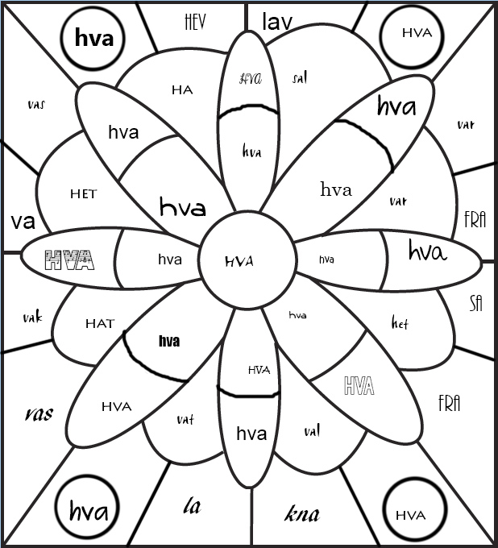

Fargelegg ukas øveord «hva»

Skriv ukas øveord minst 3 ganger:  
  
________________________________________________________________________________________________________________________________________________________________________________________________________________________________________________________________________________________________________________________________________________________________________________

Lag en setning med ukas øveord i seg:  
  
___________________________________________________________________________________________