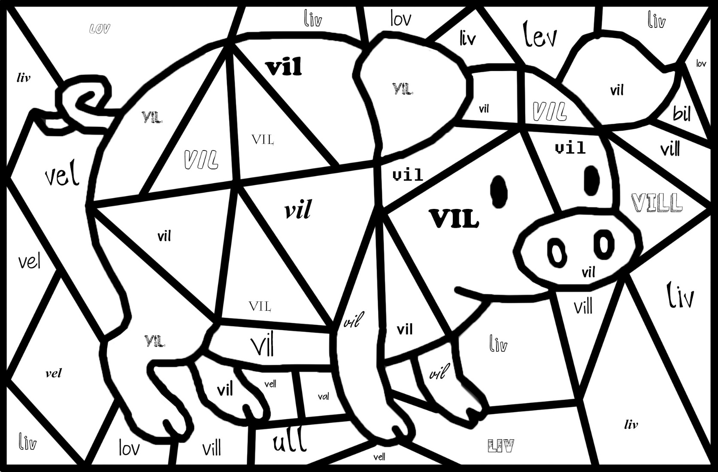

Skriv ukas øveord minst 3 ganger:  
  
________________________________________________________________________________________________________________________________________________________________________________________________________________________________________________________________________________________________________________________________________________________________________________

Lag to setninger med ukas øveord i seg:  
  
___________________________________________________________________________________________

Fargelegg ukas øveord «VIL»